**LAB 8**

Name:Huda Tayyab

Sap Id: 35483

Course: CN LAB

**TASK 1:**

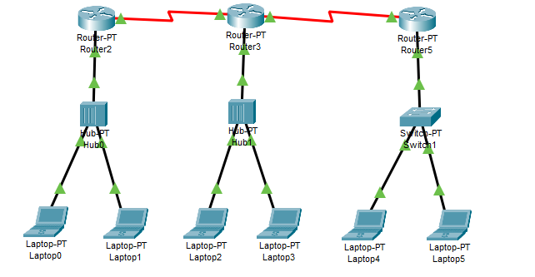

Using ping to know if routers are connected

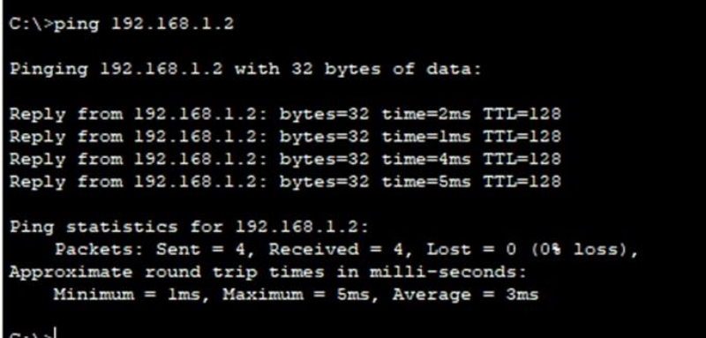

**Task 2:**

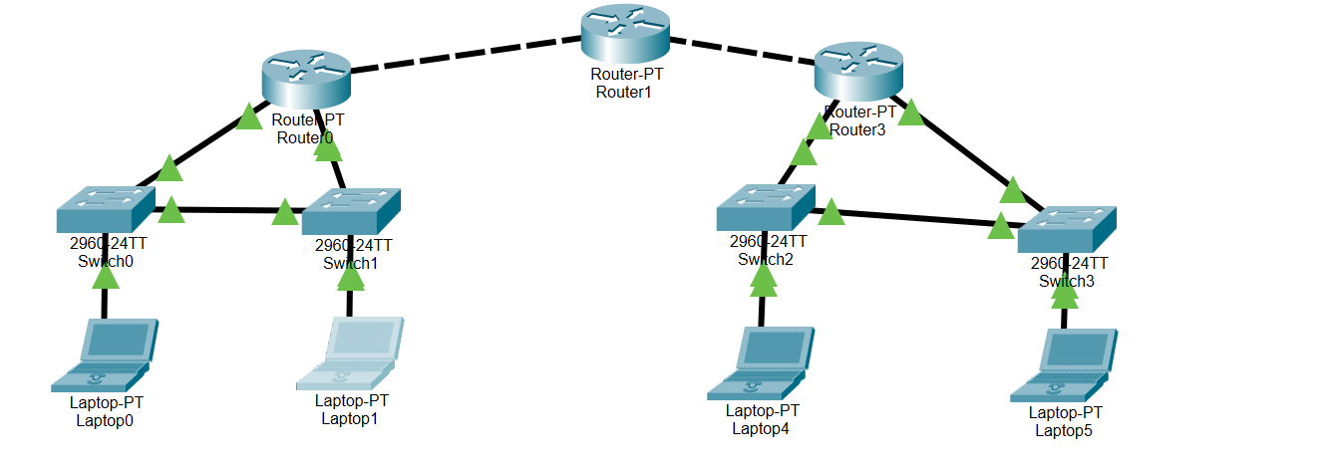

Using ping to find out if routers are connected

